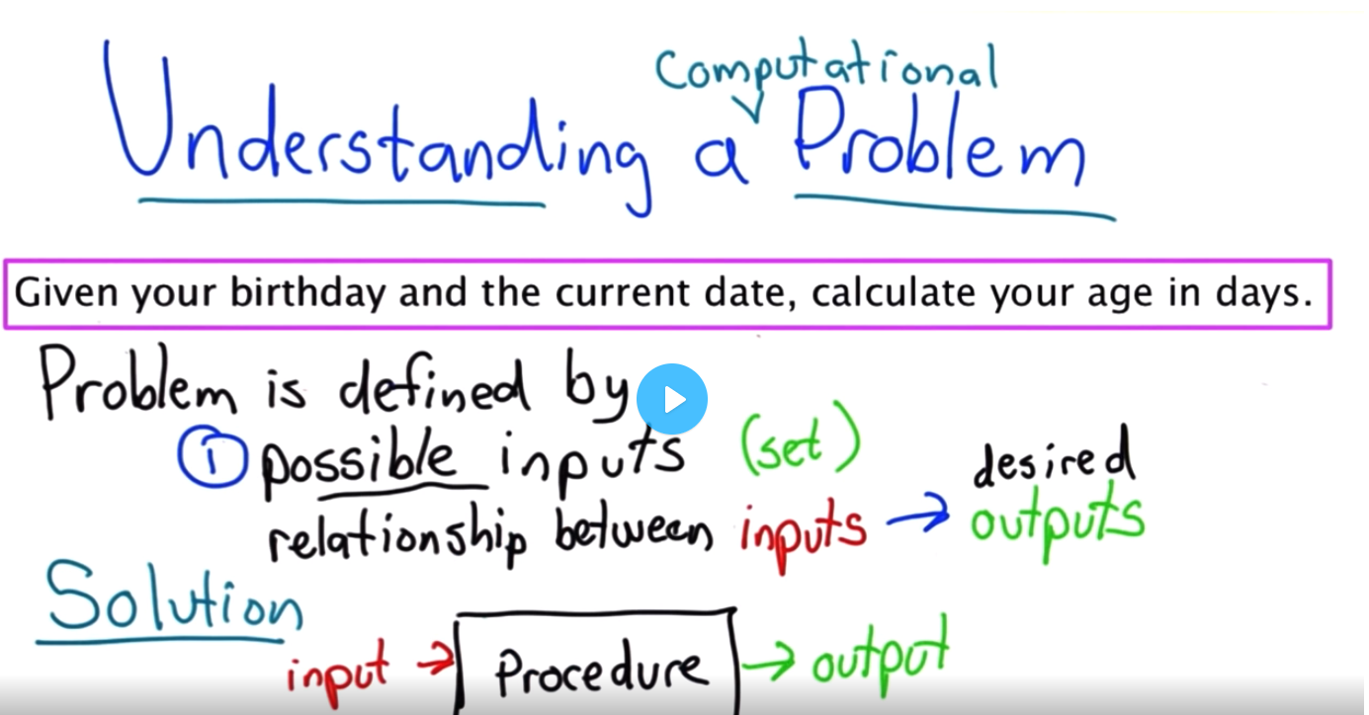

Input, output

1. Don’t panic
2. What are the inputs
3. What are the outputs
4. Solve the problem

Next:  
Workout some examples, **relationship** between input,output, testcases.

How to solve the problem as a human. Then move to code. **On paper**.

Write algoritm. Pseudocode.

Dates, df, are all the inputs are valid?1st data 2nd Second date must not be older than 1: invalid input

How input are encoded? (yyyy,mm,dd)

Output return a number because we can do things with return value rather printing it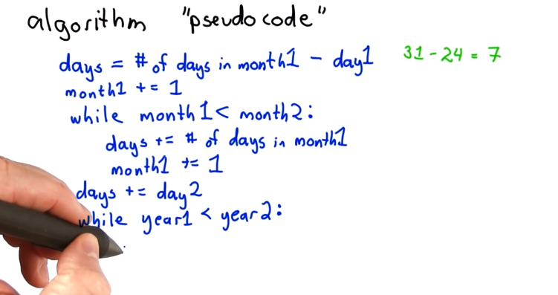

22 Continue

First code: writing a block that makes the solution to work. Solve with a single simple case.

Break into simple parts so that we can see our progress.

Write simple small codes that work

No need to figure out all the details. Consider that you will proscastinate later

Quiz not taken. Till 35 fin.